Privacy Notice



Contents | Page
- Introduction | 3
- About us | 3
- How we get the personal information and why we have it | 4
- Who do we share your personal information with | 8
- Marketing | 10
- Visitors to our website and social media platforms | 10
- How we store your personal information | 11
- Your data protection rights | 12
- Queries and complaints | 12
- Changes to privacy notice | 12

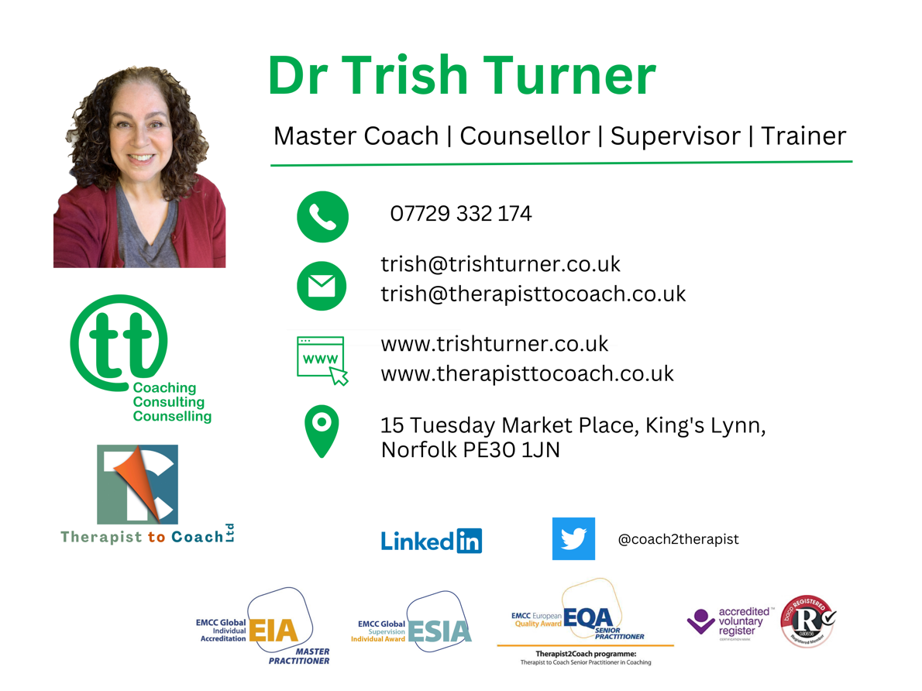

Privacy notice

- Introduction

Your privacy is a top priority. Therapist to Coach Ltd (hereafter known as “T2C”) committed to always being a good custodian of your personal information, handling it in a responsible manner, and securing it with industry standard administrative, technical and physical safeguards.

T2C follows two guiding principles when it comes to your privacy:
- transparency – T2C works hard to be transparent about what personal information is collect and process; and
- simplicity – T2C try to use easy-to-understand language to describe the privacy practices to help you make informed choices

In this policy, T2C will tell you:

- How T2C get your personal information and what sort of information;
- what purpose T2C are processing it for;
- why T2C are able to process your information;
- how long T2C store it for;
- whether there are other recipients of your personal information;
- how to request your information or make a complaint

T2C adheres to current data protection legislation, including the General Data Protection Regulation (EU/2016/679) (the GDPR), the Data Protection Act 2018 and the Privacy and Electronic Communications (EC Directive) Regulations 2003.

T2C also adheres to the ethical guidelines regarding protecting client privacy and confidentiality set by the United Kingdom Council for Psychotherapy (UKCP), the British Association for Counselling and Psychotherapy (BACP) and the European Mentoring & Coaching Council (EMCC Global).

- About me

Dr Trish Turner is the Founder, Managing Director and Lead Tutor for Therapist to Coach Ltd (Company number 14414541) providing coach training specifically aimed at counsellors, psychotherapists and psychologists.

T2C is registered as a data controller with the Information Commissioner's Office (ICO). My registered number is reference: ZB510461 and you can check it via this link: https://ico.org.uk/ESDWebPages/Entry/ZB510461.

The T2C registered business address is: 2 The Boltons, South Wootton, King’s Lynn, Norfolk PE30 3NQ, however, all correspondence should be addressed to the office at 15, Tuesday Market Place, King’s Lynn, Norfolk PE30 1JN

T2C operate this website: https://www.therapisttocoach.co.uk

If you have any queries about this privacy notice or about any aspect of T2C data management, please contact me as the Data Protection Lead at trish@therapisttocoach.co.uk.

T2C will update this privacy notice regularly to ensure it continues to comply with the latest regulations and best practice. This privacy notice was last amended on 7th August 2023.

- How I get the personal information and why I have it

Most of the personal information I process is provided to me directly by you for one of the following reasons of providing training or workshop services

In the following sections, I explain this in more detail for each service.

Under the General Data Protection Regulation (GDPR), the lawful bases I rely on for processing this information are:

- Your consent. You are able to remove your consent at any time. You can do this by contacting trish@therapisttocoach.co.uk
- I have a contractual obligation.
- I have a legitimate interest.

Training services

As part of my training services, I ask all of my course participants to provide certain types of information so that I am able to process their application create a record on my database and support their learning.

This includes:

- Name
- Home address
- Work address
- Preferred telephone number(s)
- Preferred email address
- Organisational Membership details, including proof of membership (e.g., UKCP, BACP, EMCC, BPS)
- Previous training details, including copies of certificates (to ensure eligibility and for accreditation purposes)
- Indemnity Insurance information
- Skype/Zoom/MS Teams contact details
- Any special requirements (such as dietary needs and disability access (if attending a course in-person), learning support needs etc).
- Your correspondence with and from me.

Course participants will complete and submit a portfolio of evidence with the purpose of demonstrating that they have met the criteria of the course in order to pass. Data that will be collected are forms, case studies, assignments, feedback forms from coachees and other written items provided by the participant. They will also submit a 40-minute video recording of themselves and a client, demonstrating coaching with a coachee (the client).

The portfolio is likely to be emailed by the participant to the assessors, or if it is too big for the participant’s email system, they might give us access via dropbox or will be given a dropbox folder by the me/my administrator.

The portfolio, which includes a video recording of their face and voice via zoom recording.

The portfolio they submit contains their thoughts and ideas, in the form of case studies and reflective journals etc (training materials completed by the participant) plus the video contains a zoom recording they have made, which includes themselves and their coachee. The participant adds their signature to the portfolio to confirm it is their work.

As independent practitioners, Participants are responsible and accountable for ensuring their own compliance with GDPR when requesting permission to gather named feedback from their coachees and for gaining permission for the recording, how it will be used and stored.

- Who I share your personal information with

Rest assured that what is said in our sessions will be kept confidential. I am a registered and accredited member of the UK Council for Psychotherapy (UKCP), a registered member of the British Association of Counselling & Psychotherapy (BACP) and a member of the European Mentoring and Coaching Council (EMCC Global) and I abide by their professional codes of ethics. Confidentiality will only be broken if there are legal or ethical obligations to disclose, for example, if you disclose abuse/neglect of a child or vulnerable adult, or say something else that implies serious harm to yourself or others, or if a court of law requires me to disclose information.

I will never sell your data. I will never pass on your contact details to any third-party organisations for the purposes of sales, marketing or research.

I share a limited amount of personal data with third parties in order to provide services to you and to fulfil legal obligations in respect of tax and accounting purposes.

I use an administrator, who carries out basic tasks such as ensuring course participants have submitted all the correct information for the course, or to cancel or rearrange appointments in the event of my ill health. I currently use: JT Admin Solutions.

I have regular supervision support, so I may discuss my work with my supervisor. This would be done without identifying my clients or course participants and my supervisor is a counsellor and coach who also abides by the UKCP, BACP and EMCC Global code of ethics regarding confidentiality.

If your appointments are paid for or arranged via a third party, for example, your employer or an insurance company, the only information shared with the third party is your dates of attendance and non-attendance for invoicing and payment purposes.

A list of third party applications I regularly use (in addition to email providers) includes:

- Zoom and Skype
- Calendly
- Invoice2go
- Dropbox

Zoom and Skype are video platforms that enable us to meet online for you to use my services. I may also use other video platforms, at your request, such as MS Teams.

I use Calendly to provide you with access to my diary to enable you to book appointments with you. You enter your name and contact details and information of the appointment is held in order for you to add it to your own calendar, receive appointment reminders and connect on the day.

I use Invoice2go to create and send invoices to you. I use data from this app for legitimate tax purposes.

I use Dropbox to store portfolio information submitted by course participants. This allows them to send the information to me and for me to share it for the purposes of assessment, quality assurance and accreditation.

Any third-party applications that I use, such as those listed above, are all responsible for holding your data responsibly and have their own privacy notices and protocols, for which I am not responsible.

If you are a course participant, I will need to share your data with the required organisations to fulfil my duties as a training provider. A list of those agencies/organisations are detailed as follows;

- EMCC global (accrediting professional body): https://www.emccglobal.org
- Helen Cottrill (quality assurance): https://www.helencottrill.co.uk
- Katherine Powell (assessment): https://leadwithoutlimits.co.uk
- Katherine Long (participant supervision): https://www.evolutionod.com

In some circumstances, I may be legally required to provide copies of my notes to the police or a court.

- Marketing

I may use your personal information to tell you about relevant opportunities, this is what I mean by ‘marketing’. For course participants this may be a vacancy with an employer or work opportunities that may be suitable, or for the opportunity to progress to higher or additional qualifications or professional development. It might also be about further services I offer that I feel may be of interest to you, such as group supervision or a workshop.

The personal information I have is made up of what you tell me, the data I may have collected, or from third parties I work with. I study this to form a view of what I think you may want or need, or what may be of interest to you.

I may also ask you for and use your feedback and/or testimonials on my services in my marketing and I will ask you to for your written consent to do this. I can only use your personal information to contact you if I have either your consent, or a ‘legitimate interest’. This is when I have a business reason to do so, and it must not go against what is right and best for you.

You can ask me to stop contacting or update your choices at any time by contacting me.

- Visitors to my website and social media platforms

  - Website

My website (www.therapisttocoach.co.uk) uses cookies and Google Analytics. Almost all websites use cookies which are small files that get put on your computer by websites as you surf them. These cookies can store lots of information which can have privacy implications. Google Analytics is a service provided by Google that gathers anonymous data on how people are using websites and then provides visitor statistics, details of page views etc. This service is used by many website owners as the data helps website owners to improve their websites. Read the Google Analytics privacy notice.

I use Wordpress as the content management system for my website - find out about the Wordpress privacy notice: https://wordpress.org/about/privacy/

If you fill in a form on my website, that data will be temporarily stored on the web host before being sent to me. By accessing the website, you are consenting to the information collection and use practices described in this privacy notice. Should you choose to contact me using the ‘contact me’ form on the website none of the data that you supply will be stored by the website or passed to any third-party data processors. Instead, the data will be collated into an email and sent to me over the Simple Mail Transfer Protocol (SMTP). The SMTP server I use is protected by ‘SSL’, meaning that the email content is encrypted before being sent across the internet. The email content is then decrypted by local computers and devices.

Where I provide links to websites of other organisations, this privacy notice does not cover how that organisation processes personal information. I encourage you to read the privacy notices on the other websites you visit.

I use Google to make the website more helpful to you as a site visitor however most of this comes with its own cookies, which I do not control these cookies so I cannot guarantee what they do. In many cases the cookies are used to generate identical information to Google Analytics and indeed use Google Analytics, so opting-out of Google Analytics will also opt you out of these cookies too. You can opt out of Google analytics and other Google services here – http://tools.google.com/dlpage/gaoptout and https://www.google.com/dashboard/.

  - Social media

I have a presence on LinkedIn, Facebook, Instagram and Twitter. To find out how these companies use your data and how you can control the way they use your data please refer to their privacy policies, which should be available on their websites. If you are a counselling client, I will not usually connect with you on social media platforms in order to maintain confidentiality and privacy and to keep the boundaries of our counselling relationship, even after you have finished using my services.

- How I store your personal information
Paper copies of your information are securely stored in a locked filing cabinet at my home office, which is secured by an alarm. If we are working together in-person, they may also be anonymised paper notes (with no identifiable information) stored in a locked filing cabinet at my consulting room on the Tuesday Market Place (address at the top of the page).

Electronic information is held on my smart phone and tablet (which are password and facial-recognition protected) and computers (which are password protected).

Retaining your notes and information after the service has ended ensures that I can continue to offer you an efficient service if you make contact again. I keep your information for the industry standard seven years after the service has ended. After seven years, I will then dispose of your paper information by shredding it and any electronic data by deleting it (then emptying the electronic ‘bins’) from my electronic devices.

- Your data protection rights

Under data protection law, you have rights including:

- Your right of access - You have the right to ask us for copies of your personal information.
- Your right to rectification - You have the right to ask us to rectify personal information you think is inaccurate. You also have the right to ask us to complete information you think is incomplete.
- Your right to erasure - You have the right to ask us to erase your personal information in certain circumstances.
- Your right to restriction of processing - You have the right to ask us to restrict the processing of your personal information in certain circumstances.
- Your right to object to processing - You have the the right to object to the processing of your personal information in certain circumstances.
- Your right to data portability - You have the right to ask that we transfer the personal information you gave us to another organisation, or to you, in certain circumstances.

You are not required to pay any charge for exercising your rights. If you make a request, I have one month to respond to you.

Please contact me: trish@therapisttocoach.co.uk or write to me at the address at the top of the page if you wish to make a request.

- Queries and complaints

If you have any questions about this privacy policy or the way in which I handle your personal information or you have a complaint, you can contact me via phone on 07729 332174 or email at trish@therapisttocoach.co.uk

You can also complain to the Information Commissioner’s Office (ICO) if you are unhappy with how I have used your data:

Helpline number: 0303 123 1113 website: https://www.ico.org.uk

- Changes to privacy notice

This privacy notice may be updated from time to time, so please check occasionally for any updates.

